SOFTWARE VERSION DESCRIPTION
FOR THE
ETHIIC Firmware

Prepared by
VCortex Ltd

COPYRIGHT 2014 VCortex Ltd ©
This document contains valuable and confidential information proprietary to VCortex Ltd. The recipient of this document shall not disclose its contents, in whole or in part, to any third party without VCortex’ prior written approval.
REVISION HISTORY

SVD  VERSION | SVD  DATE | RELEASED SOFTWARE VERSION
1.0 | 16/11/14 | 2.11 STSYS

TABLE OF CONTENTS
1. SCOPE 3
1.1. IDENTIFICATION 3
1.2. CSCI OVERVIEW 3
1.3. DOCUMENT OVERVIEW 3
2. REFERENCED DOCUMENTS 3
3. VERSION DESCRIPTION 4
3.1. INVENTORY OF MATERIAL RELEASED 4
3.2. INVENTORY OF SOFTWARE CONTENTS 4
3.3. CHANGES INSTALLED 5
3.4. ADAPTATION DATA 5
3.5. INTERFACE COMPATIBILITY 5
3.6. RELATED DOCUMENTS 5
3.7. INSTALLATION INSTRUCTIONS 5
3.8. POSSIBLE PROBLEMS AND KNOWN ERRORS 7
3.9. The BUILD INSTRUCTIONS FOR THE RELEASE 7
4. NOTES 8
4.1. ACRONYMS AND ABBREVIATIONS 8
Appendix A Development Environment 9
Appendix B BUILD/MAKE Instructions for this Release 10
Appendix C The List of source code files 11

LIST OF TABLES
Table 1- Main Released Executable File 6
Table 2- Additional Released Components 6

TABLE OF FIGURES
Figure 1: Connecting the burning cable to J2 5
Figure 2: LM programmer - Configuration selection 6
Figure 3: "Program" tab settings 7

SCOPE

IDENTIFICATION
This Software Version Description (SVD) identifies and describes the release of the ETHIIC FirmWare CSCI.
The current release version 2.11 STSYS is an initial version.

CSCI OVERVIEW
The CSCI is a firmware SW that runs on TIVA MPU (TM4C1294NCPDTI from TI). The firmware controls the various IO’s, connects to the host computer through UDP commands, and implements HTTP server with board parameters and statistics.

DOCUMENT OVERVIEW
This SVD describes the contents of the released software identified in paragraph 1.1 above.
This SVD is formatted in the style recommended by Data Item Description DI-IPSC-81442, as tailored to VCortex needs and needs of this project.
- Chapter 2 lists referenced documents
- Chapter 3 describes the released version
- Chapter 4 contains a list of acronyms and abbreviations
- Appendix A: Development Environment
- Appendix B: Build/Make Procedures
- Appendix C: The List of Source Code Files

REFERENCED DOCUMENTS
- DI-IPSC-81442 Software Version Description
- ETHIIC Specification ver 1.3.docx

VERSION DESCRIPTION

INVENTORY OF MATERIAL RELEASED
This software release consists of the contents of .bin file, .cpp and .h files, as well as project files.

INVENTORY OF SOFTWARE CONTENTS
Downlowdable BIN files:
FILE NAME | DATE | SIZE | CHECKSUM  (If applicable)
ETHIIC.bin | 14-nov-14 | 308kb
Table 1- Main Released BIN File

CHANGES INSTALLED
None

ADAPTATION DATA
None.

INTERFACE COMPATIBILITY
N/A

RELATED DOCUMENTS
All the related documents for this software version release are listed in para 2.3 of this document.

INSTALLATION INSTRUCTIONS
The program is downloaded with the use of LM Flash programmer utility from TI.
LM Flash Programmer is a free flash programming utility intended to be used with Texas Instruments Tiva™ C Series and Stellaris® microcontrollers, development boards, or evaluation boards. It can be downloaded from http://www.ti.com/tool/LMFLASHPROGRAMMER.
Burning steps:
- Connect the IOX Burning Tool to the computer USB and to J2.
 IMPORTANT: make sure that the red line of the flat cable is on the side of pin 1 of J2, as seen in the following figure:
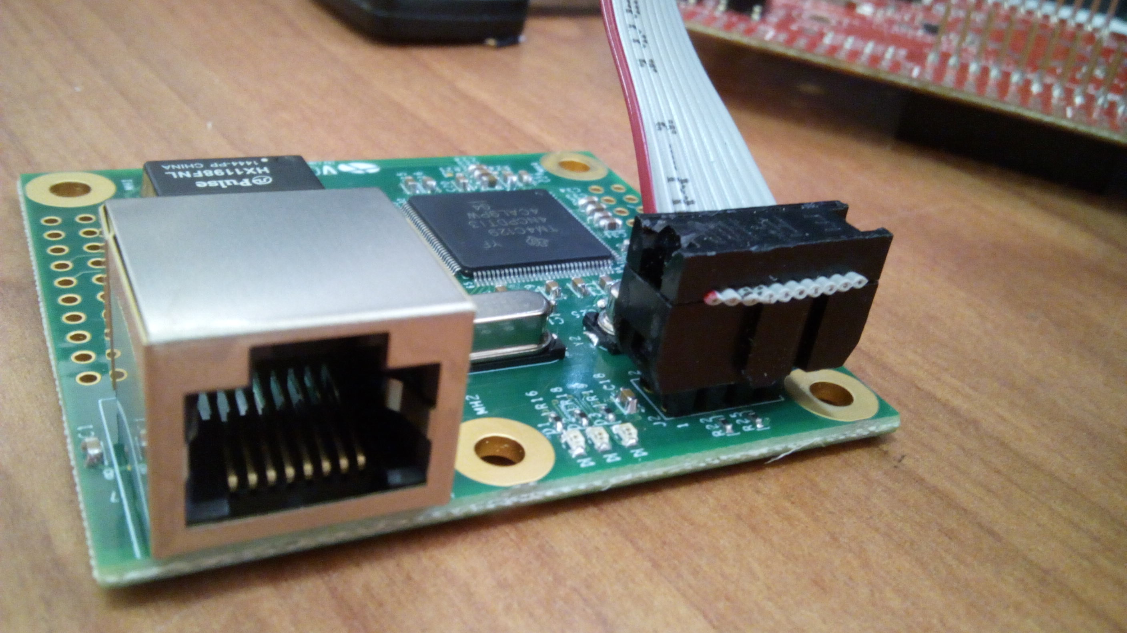
Figure 1: Connecting the burning cable to J2

- Start LM Flash programmer
- Select “TM4C1294XL Launchpad” in the “Configuration” tab as seen in the following figure.
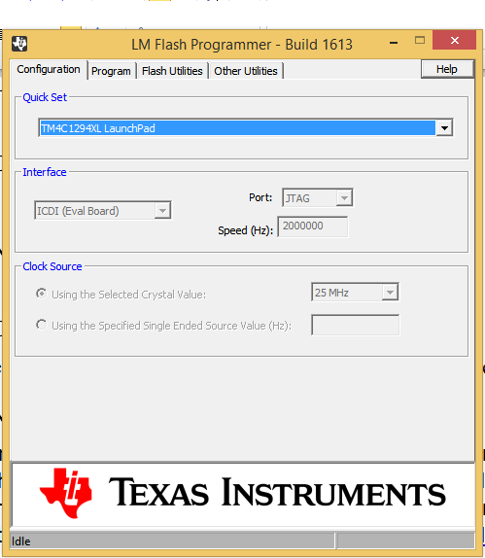
Figure 2: LM programmer - Configuration selection

- Select the BIN file in the “Program” tab. Make sure all the options are selected as shown in the figure below, and press “Program” button.
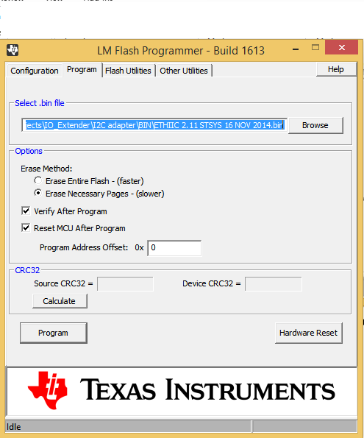
Figure 3: "Program" tab settings

POSSIBLE PROBLEMS AND KNOWN ERRORS
None

The BUILD INSTRUCTIONS FOR THE RELEASE
The instructions to Make/Build the BIN from the source files, using the command and batch files and the development environment given in Appendix A, are given in Appendix B.

NOTES

ACRONYMS AND ABBREVIATIONS

CSCI | Computer Software Configuration Item
N/A | Not Applicable
para | Paragraph
SVD | Software Version Description
SW | Software
Ver | Version

Appendix A Development Environment

- Development Environment Software
TOOL | NAME | VERSION | Manufacturer
Development environment | Code Composer Studio | 6.0.1 | Texas Instruments
Programming language | C
Operating system | None | - | -

- Development Environment Hardware
None

Appendix B BUILD/MAKE Instructions for this Release
The build procedure is a regular Code Composer build, with no special steps.

- Start Code Composer Studio
- Set the Workspace to the folder where the ETHIIC project resides
- Select the ETHIIC project (mouse left button)
- Select Project->Build Project on the top menu

Appendix C The List of source code files

Directory of ETHIIC

Date | Time |  | Size
05-Dec-14 | 5:41 | PM | 424 | .ccsproject
05-Dec-14 | 5:41 | PM | 28,750 | .cproject
05-Sep-14 | 3:45 | PM | 2,205 | .project
26-Jul-14 | 4:36 | PM | 18,406 | cgifuncs.c
26-Jul-14 | 4:36 | PM | 2,186 | cgifuncs.h
24-Jul-14 | 4:18 | PM | 9,736 | enet_fs.c
05-Sep-14 | 4:36 | PM | 2,135 | enet_fs.h
01-Nov-14 | 4:33 | PM | 1,685,425 | enet_fsdata.h
24-Jul-14 | 4:18 | PM | 2,802 | enet_lwip_ccs.cmd
05-Dec-14 | 6:50 | PM | 57,867 | ETHIIC.c
21-Jul-14 | 6:07 | PM | 4,378 | httpd_structs.h
26-Jul-14 | 4:36 | PM | 8,142 | io.c
26-Jul-14 | 4:36 | PM | 2,108 | io.h
24-Sep-14 | 1:25 | PM | 19,052 | lwipopts.h
31-Aug-14 | 9:23 | PM | 18,986 | lwipopts_31_aug.h
21-Jul-14 | 6:07 | PM | 26 | macros.ini_initial
31-Oct-14 | 1:06 | PM | 40 | makefsfile.bat
21-Jul-14 | 6:07 | PM | 43,520 | makefsfile.exe
24-Jul-14 | 4:18 | PM | 13,444 | startup_ccs.c
13-Sep-14 | 12:36 | PM | 13,581 | swupdate.c
21-Jul-14 | 6:07 | PM | 2,644 | swupdate.h
21-Jul-14 | 6:07 | PM | 1,084 | target_config.ccxml
 | 24 | File(s) | 13,371,967 | bytes

Directory | Of | ETHIIC\fs
Date | Time |  | Size
24-Jul-14 | 4:18 | PM | 218 | 404.htm
05-Sep-14 | 7:31 | PM | 1,292 | about.htm
06-Jul-13 | 11:12 | AM | 1,078 | app.ico
24-Jul-14 | 4:18 | PM | 443 | block.htm
24-Jul-14 | 4:18 | PM | 180,251 | block.jpg
01-Nov-14 | 11:40 | AM | 6,566 | board_data.ssi
01-Nov-14 | 11:41 | AM | 1,951 | index.htm
06-Sep-14 | 11:00 | AM | 4,448 | javascript.js
26-Jul-14 | 4:36 | PM | 399 | javascript_load.js
01-Nov-14 | 11:41 | AM | 7,343 | Statistics.ssi
01-Nov-14 | 4:33 | PM | 11,132 | Statistics2.ssi
24-Jul-14 | 4:18 | PM | 1,632 | styles.css
05-Sep-14 | 6:19 | PM | 35,454 | topMenuBG.jpg
 | 14 | File(s) | 252,207 | bytes

Directory | of |  | ETHIIC\third_party\lwip-1.4.1\apps\httpserver_raw
Date | Time |  | Size
05-Sep-14 | 4:28 | PM | 74,862 | httpd.c
 | 1 | File(s) | 74,862 | bytes

